**WasteWise- AI that sorts out waste types**

Project by- Ansh Barat

For IngeniumSTEM Winter Hacks 1.0

Logic of the code: according to the recognition result obtained from the training model, each category will be assigned the best disposal method which will be displayed next to the sprite and spoke

Attach appropriate screenshots and explain the entire coding process briefly. This should be done for all the codes you have and using different colored code blocks explaining their needs and their use. Explain which block does what.

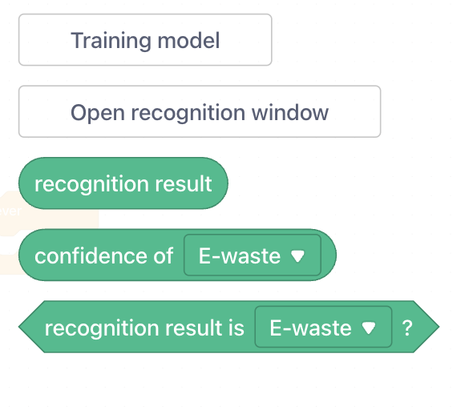

In the teachable machine extension blocks these three blocks give us the result of the model. Whatever is shown in the camera, will be detected and used as the recognition result.

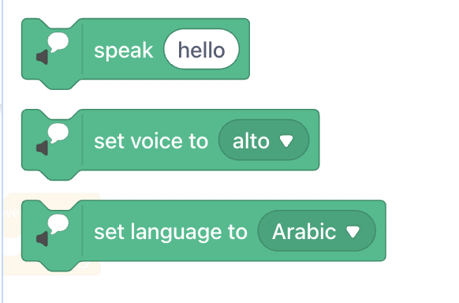

In the text to speech extension blocks these three blocks give us the freedom to convert text to voice messages, this is how our sprite will guide the users for the best disposal method.

Let’s see the detailed code for the project that does the magic of bringing AI waste sorting to life!

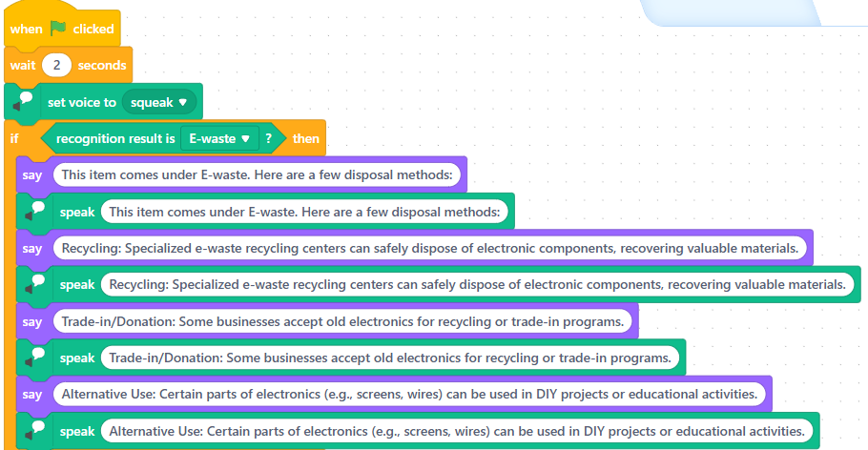

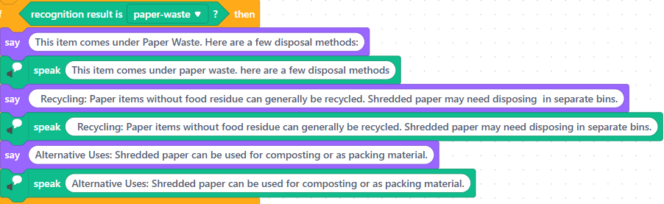

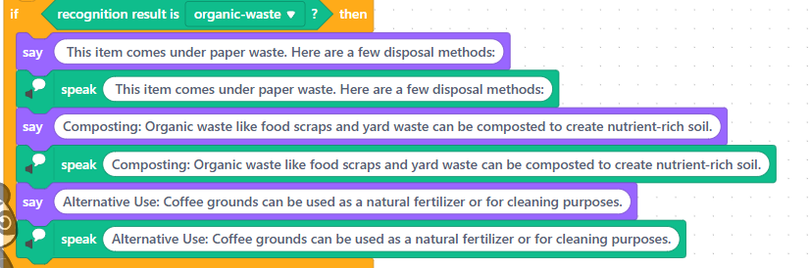

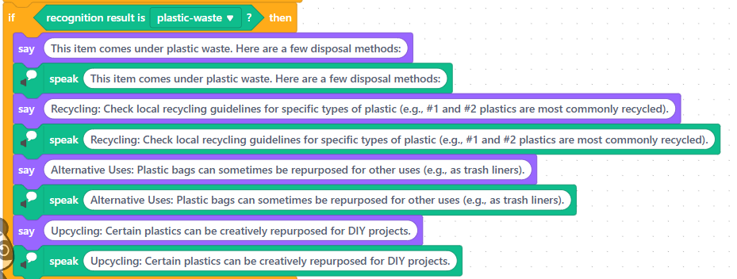

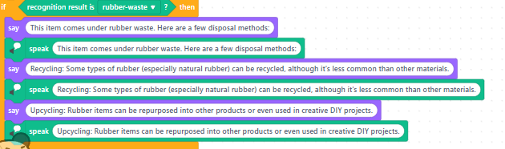

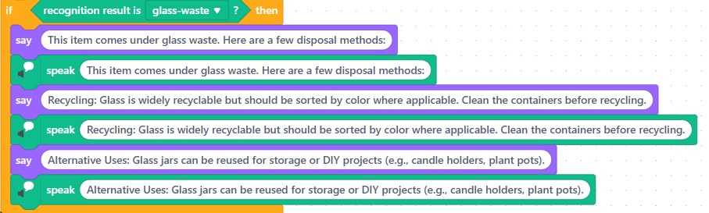

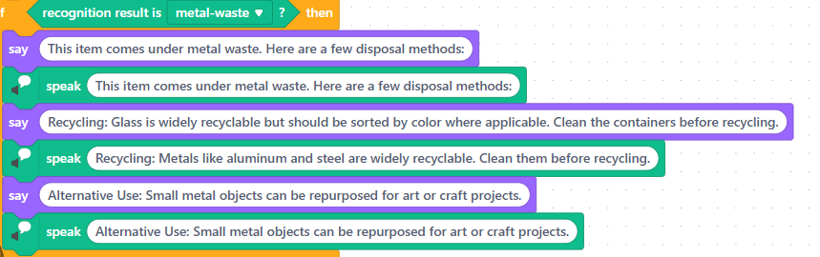

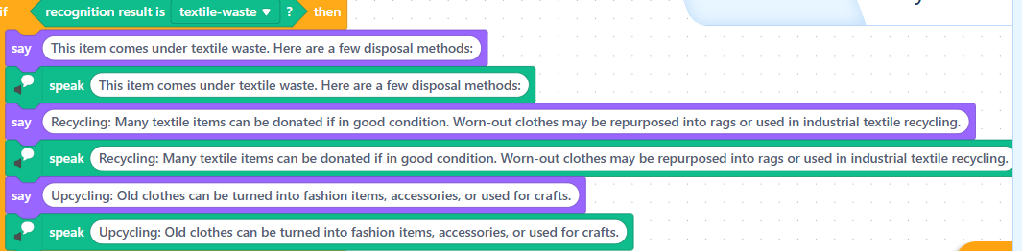

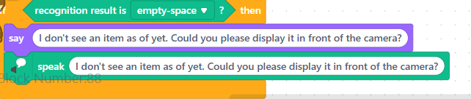

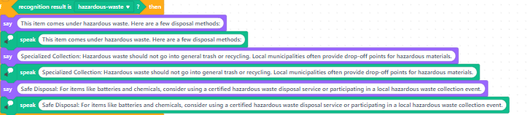

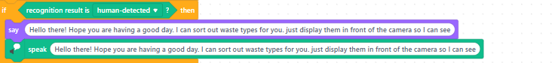

The green flag is the symbol to click when you want the code to start. The ‘wait 2 seconds’ is for you to show the object properly. The set voice block has multiple voice presets, so I chose the one that sounds most like a panda (which is the sprite for this project). Then, the if blocks are used for the condition where a specific waste type is shown. “If” laptop is shown, which comes under e-waste, then the training model will allocate the image as e-waste and the sprite will give the disposal method for that category. The recognition result block shows which result is recognised by the AI from the training model or teachable machine. The ‘say’ block is the one that helps display the text which is written in the white space on the screen and the ‘speak’ block uses the voice set earlier to say what is typed in the white space.